Name: Ayanda Majola
Student Number: ST10467169
Module Name: Introduction to Web Development
POE 1: Website Pitch

Business 1: Just Life Properties

  - Motivation for Developing the Website
In the modern digital environment, a website is an important asset when it comes to business growth, communication and competitive advantage. One of the primary benefits of a website is the ability it has to improve a business’s visibility and market research. (Chaffey & Ellis-Chadwick, 2019). Digital platforms allow businesses to overcome limitations that come with location and connect with a broader audience, allowing more effective customer acquisition. (Chaffey & Ellis-Chadwick, 2019)

I have chosen Just Life Properties for my assignment, and this real estate agency was selected for this project due to the significant role that digital platforms play in the modern property market, mixed with the current absence of a website for the business. This has created an opportunity to apply web development skills to address a real-world business need.

The real estate industry has undergone a substantial digital transformation, with renters and buyers relying on online platforms to search for properties in increasing amounts, they also use online platforms to compare options and gather information before making decisions (Xiao and O’Neill, 2013). As a result, having a website is no longer optional but essential for agencies that aim to remain competitive and visible in the market.

  - Objectives of Having a Website for This Business
The main objective of developing a website for the real estate agency is to establish a strong online presence that enhances visibility and competitiveness in a digital property market. As consumers continue to rely on online platforms to search for properties, a website makes it easier to reach a broader audience and remain accessible to potential clients (Chaffey and Ellis-Chadwick, 2019: Xiao and O”Neill, 2013).

Another objective is to provide an integrated platform for showcasing property listings. The website will allow the agency to present properties using detailed descriptions and images, enabling users to make informed decisions. The availability of high-quality online information has been shown to improve user satisfaction and support decision-making (DeLone and McLean, 2003, Benefield, Sirmans and Sirmans, 2019).

The website will also function as a lead generation tool by capturing potential client information through contact forms and inquiry features. This supports the conversion of website visitors into leads and aligns with digital marketing strategies that emphasise inbound customer acquisition (Chaffey and Ellis-Chadwick, 2019; Ryan, 2016).
Additionally, the website aims to strengthen the credibility and professional image of the agency. A well-designed website positively influences trust and user engagement, as consumers tend to assess businesses based on their online presence (Flaviân, GuinalÍu and Gurrea, 2006;DeLone and McLean, 2003).

Finally, the website will improve customer experience by providing 24/7 access to property information and services. This level of accessibility increases user convenience and engagement, while also supporting future digital marketing initiatives such as SEO and online advertising (Ryan, 2016; Xiao and O’Neill, 2013).

  - Resources Needed to Assemble the Website
Visual Content:
- Professional photographs of properties (interior and exterior)
- Agent/team photos
- Optional virtual tours for properties
Branding Elements:
- Company logo
- Brand colour palette
- Typography
- Brand style guides
Website Copy:
- Homepage Content
- Property Descriptions
- “About Us” section (company background and mission)
- Services offered (buying, selling, renting)
- Content page content and call-to-action
Functional Requirements:
- Property listing and search functionality
- Contact forms for inquiries
- Navigation menu for easy browsing
- Mobile responsiveness for accessibility across devices
Technical Resources:
- Domain name
- Web hosting service
- Development tools (e.g., HTML, CSS, JavaScript)
- Version control (e.g., GitHub)
Legal and Supporting Content
- Privacy policy and terms of use
- Property listing permissions
- Contact information (phone number, email, office location)
1.4. User Persona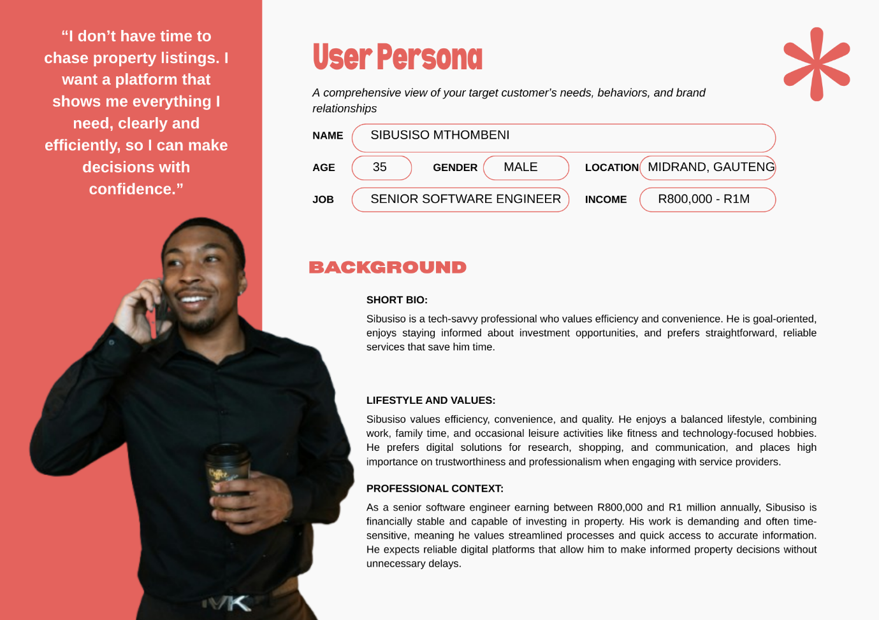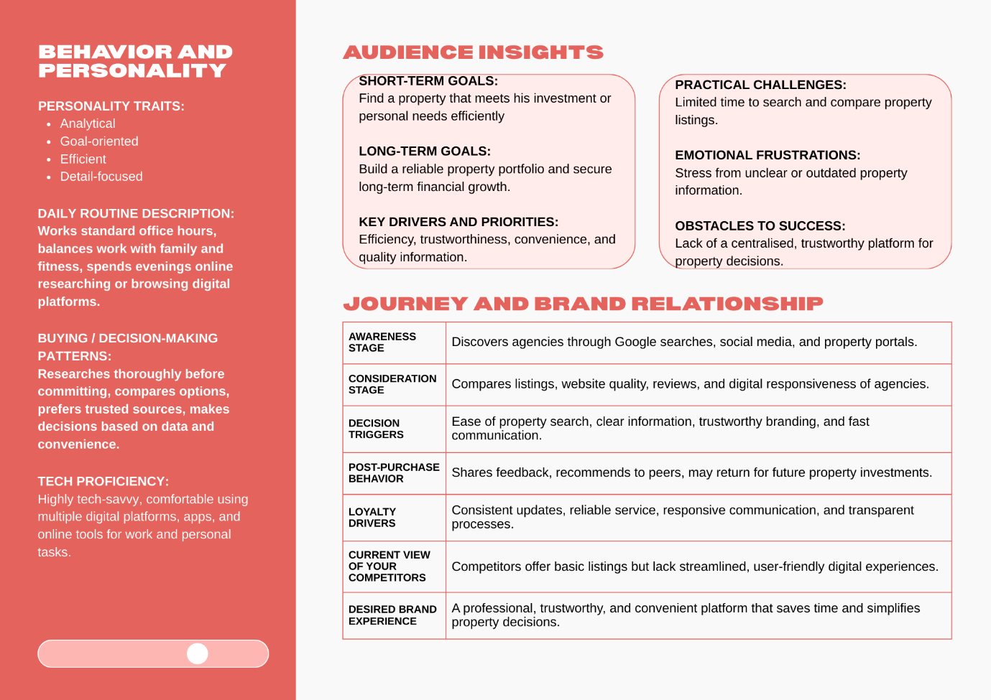
  - Sitemap
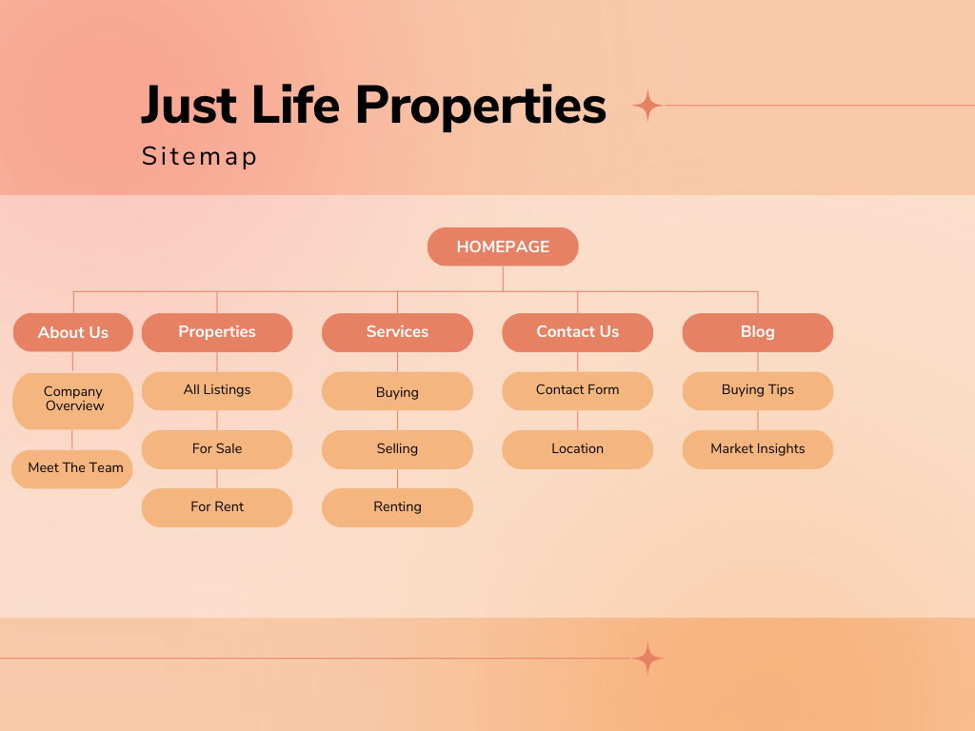

Business 2: RedX
  - Motivation for Developing the Website

In the contemporary digital economy we’re in, a website is an important too for visibility, credibility, and growth for a business. Businesses are relying more and more on digital platforms to communicate their value propositions and interact with prospective clients, this makes an online presence imperative for competitiveness (Chaffey and Ellis-Chadwick, 2019; Ryan, 2016). Without a website, businesses are at a risk of reduced visibility and limited access to potential markets, especially service-based industries where information plays a major role in decision-making (DeLone and McLean, 2003; Flaviân, GuinalÍu and Gurrea, 2006).
A website also increases credibility and trust, which are important factors influencing client engagement. Research shows that users evaluate the legitimacy and professionalism of a business based on its online presence, including website quality, usability, and content (Flavián, Guinalíu and Gurrea, 2006; DeLone and McLean, 2003). This is especially important for consulting businesses, where trust and expertise are key influencers of client decisions (Ryan, 2016; Chaffey and Ellis-Chadwick, 2019).

  - Objectives of having a website for this business
The main objective of developing a website for RedX is to set up a strong online presence that improves visibility and positions the business competitively within the consulting industry. Another objective is to communicate the company’s expertise and service offerings clearly. People rely on information to evaluate credibility and competence since marketing and financial consulting are services that are not tangible. A well-structured website allows RedX to present its services, methodologies, and value proposition effectively, thereby reducing uncertainty and supporting informed decision-making (Flavián, Guinalíu and Gurrea, 2006; DeLone and McLean, 2003).

This website will also be used as a lead generation tool by capturing potential client information through contact form forms, consultation bookings, and call-to-action.

The website will be used to build trust and credibility. Researchers indicates that users form ideas of trust based on website quality, usability, and content. A professional and informative website enables RedX to establish authority and differentiate itself from competitors in a crowded consulting market (Flavián, Guinalíu and Gurrea, 2006; DeLone and McLean, 2003).

The website also aims to support content marketing and thought leadership. By incorporating blogs, insights, or case studies, RedX can demonstrate expertise and provide value potential clients, strengthening its positioning as a knowledgeable and reliable consulting firm (Ryan, 2016; Chaffey and Ellis-Chadwick, 2019).
2.3 Resources Needed to Assemble the Website
Visual Content:
- Professional team photos
- Office/workspace images
- Corporate-style stock images (business, finance, strategy)
Branding Elements:
- Company logo
- Brand colour palette
- Typography
- Brand style guidelines
Website Copy:
- Homepage content (value proposition)
- Services pages
- “About Us” section
- Case studies or portfolio
- Contact page content and call-to-action
Functional Requirements
- Service pages for different offerings
- Contact forms and consultation booking
- Clear navigation menu
- Mobile responsiveness
Technical Resources:
- Domain name
- Web hosting service
- Development tools (HTML, CSS, JavaScript)
- Version control (e.g., Github)
Legal and Supporting Content:
- Privacy policy
- Terms of use
- Business content information
2.4 User Persona

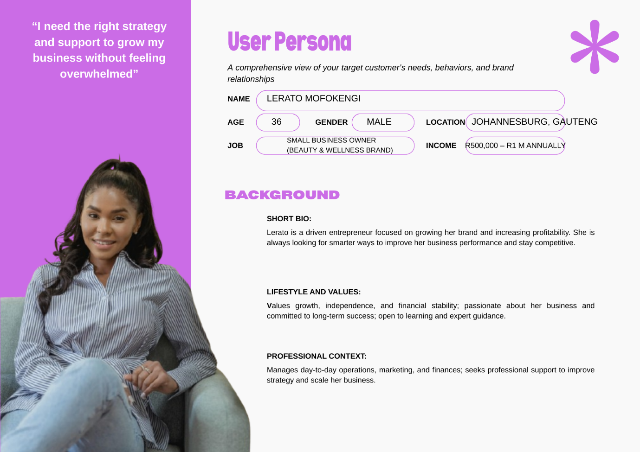

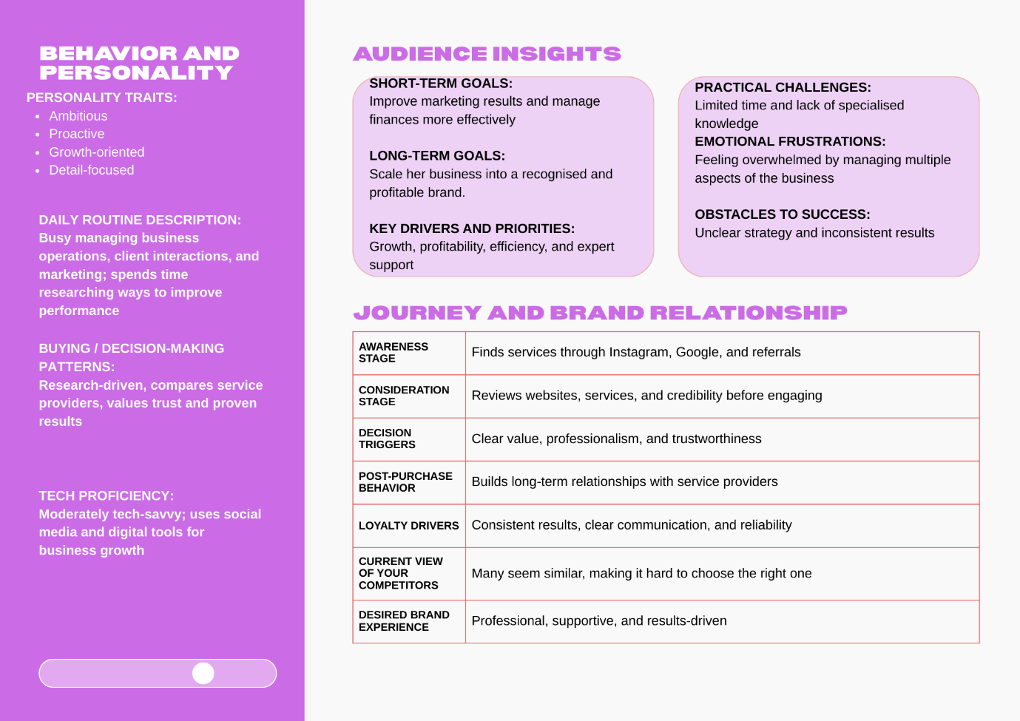
2.5 Sitemap
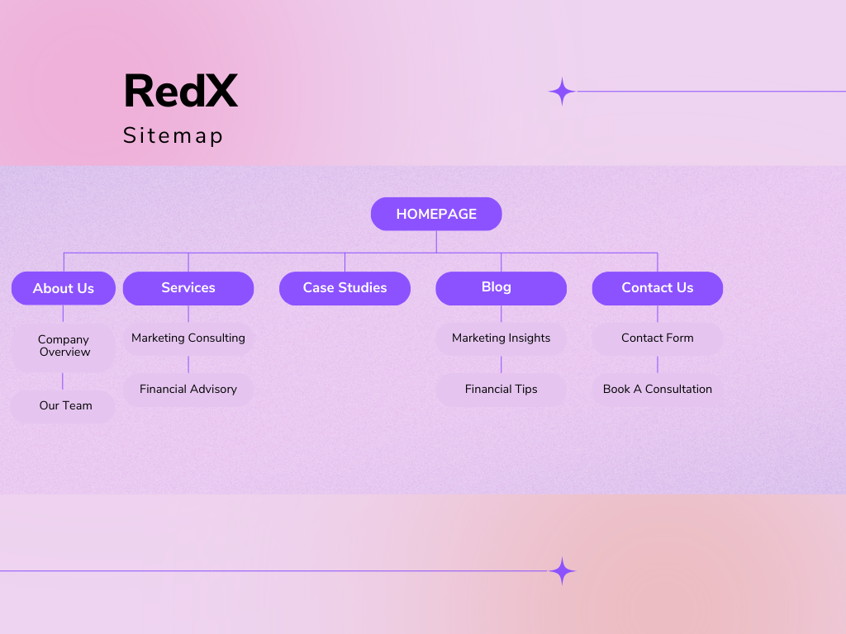

Reference List
Benefield, J.D., Sirmans, G.S. and Sirmans, C.F. (2019) ‘Real estate brokerage, agency relationships, and information’, Journal of Real Estate Literature, 27(2), pp. 171–190.
Chaffey, D. and Ellis-Chadwick, F. (2019) Digital Marketing: Strategy, Implementation and Practice. 7th edn. Harlow: Pearson.
DeLone, W.H. and McLean, E.R. (2003) ‘The DeLone and McLean model of information systems success: A ten-year update’, Journal of Management Information Systems, 19(4), pp. 9–30. Available at: https://doi.org/10.1080/07421222.2003.11045748 (Accessed: 18 March 2026).
Flavián, C., Guinalíu, M. and Gurrea, R. (2006) ‘The role played by perceived usability, satisfaction and consumer trust on website loyalty’, Information & Management, 43(1), pp. 1–14. Available at: https://doi.org/10.1016/j.im.2005.01.002 (Accessed: 18 March 2026).
Ryan, D. (2016) Understanding Digital Marketing: Marketing Strategies for Engaging the Digital Generation. 4th edn. London: Kogan Page.
Xiao, Q. and O’Neill, J.W. (2013) ‘Website quality, consumer satisfaction, and purchase intentions: The case of online real estate platforms’, Journal of Real Estate Practice and Education, 16(1), pp. 1–16.

